BANGALORE UNIVERSITY, JNANABHARATHI

Jnana Bharathi Campus, Mysore Road, Mutharayana Nagar, Bengaluru – 560056,

**DEPARTMENT OF COMPUTER SCIENCE**

**VI SEMESTER PROJECT WEEKLY REPORT**

NAME : Shabnam F

PROJECT TITLE : Implementation of Planning at Automotive Aftermarket (AA)

PLACE OF PROJECT : Robert Bosch Engineering and Business Solutions

|  |  |
| --- | --- |
| **FROM** – 03-04-2017 **TO** – 07-04-2017 | |
| The following topics were discussed and practically implemented during the above mentioned period:   * Task Lists * Creation and Working with task lists * Data Relational mapping | |
| Internal Guide Signature | H.O.D. Signature |

**TASK LISTS**

Administrators can set up task lists that instruct you in performing specific actions, to help with budget cycles. For example, a task might help you complete forms, launch business rules, or promote planning units. Tasks may display instructions, due dates, dependencies, and alerts.

**WORKING WITH TASK LISTS AND TASK**

* Steps to create task lists:
* Administration-> Manage -> Task Lists -> My Task Lists

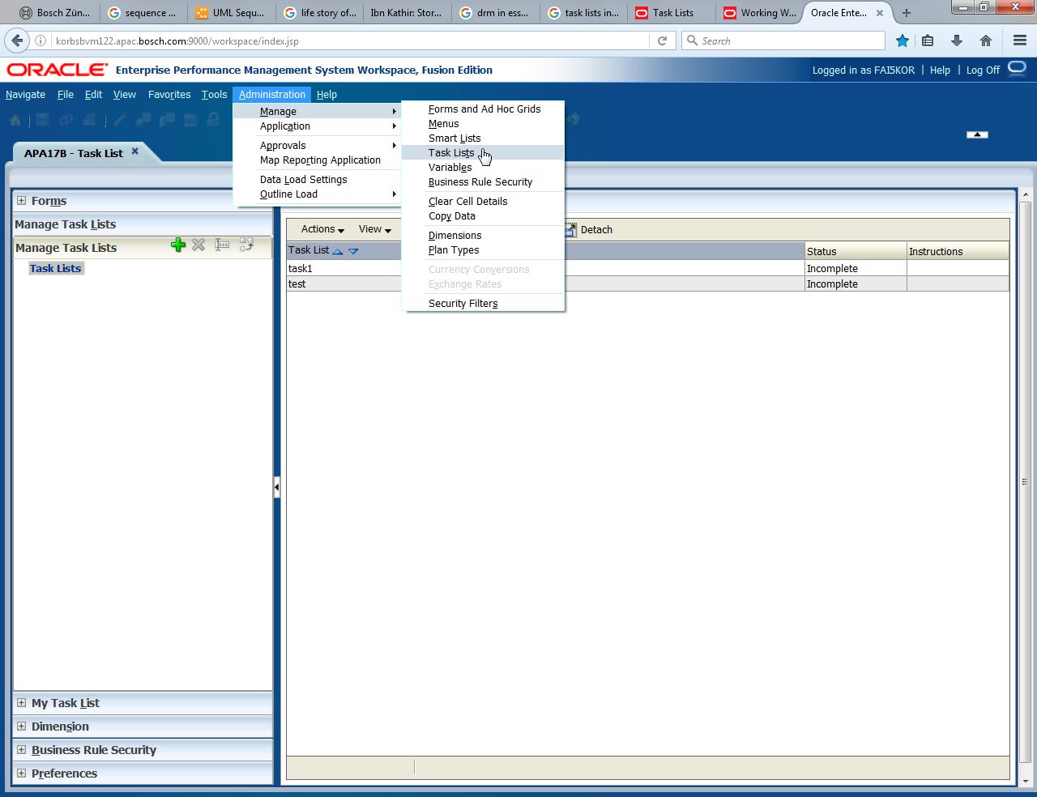

* Click on the “+” Symbol to add new task list
* Give a name to the task list

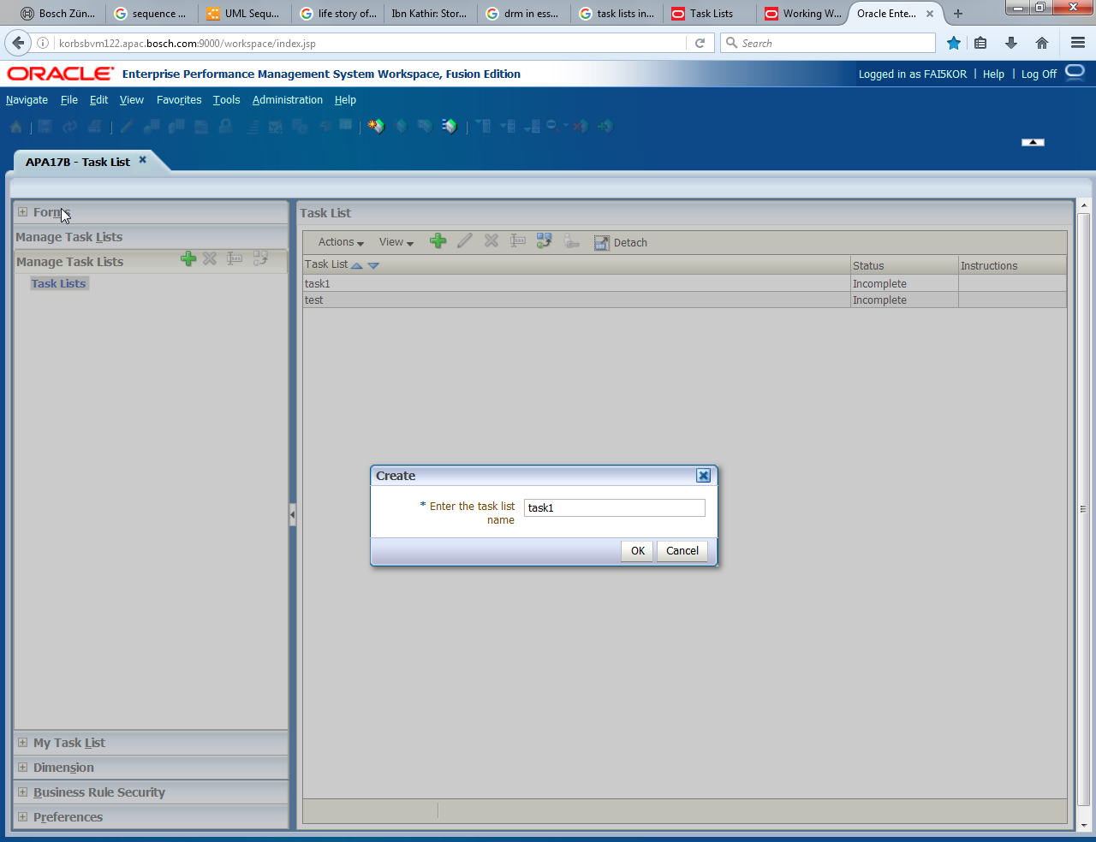

* To view your task lists:

1. Open an application and perform a task:
   * Select View -> Task List -> Task List.h
   * Select My Task List.
2. Display the status

The status of your tasks is displayed. To show a task list, select it under My Task List.

You can display the status as a Pie Chart or a Project Gantt Chart. To select how to display the task status, select the desired option from the View drop-down menu at the top right of the screen.

* + Pie Chart — shows the percentage of tasks that are complete, incomplete, or overdue. Click sections to display details about a specific task status.
  + Project Gantt Chart – You can view the status using a Gantt Chart as well
* Review information about each task. You can view this task information:
* Type—The type of task such as Web pages, forms, job console, approvals, business rules, or descriptions.

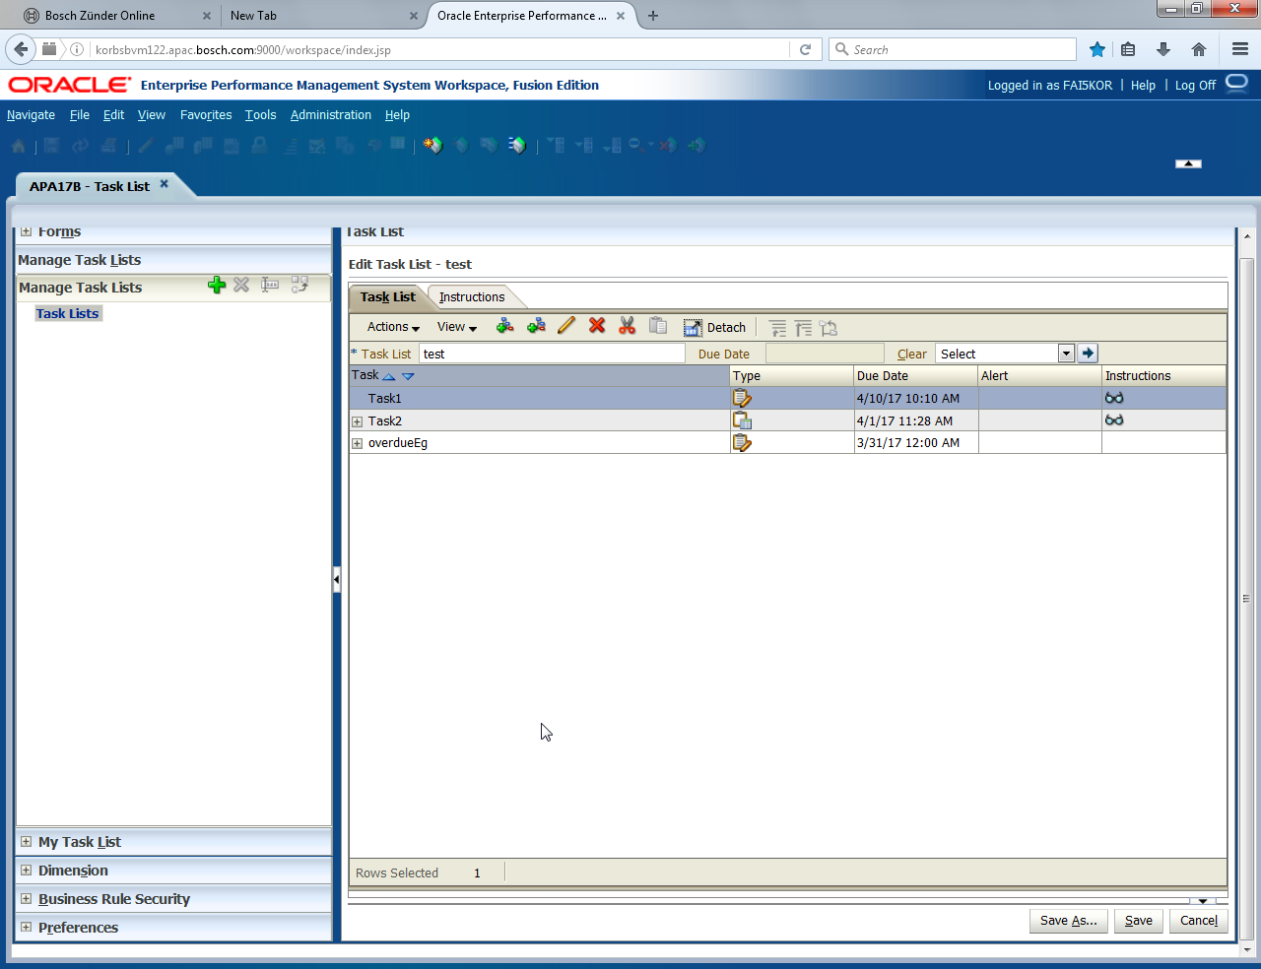

* Status:
  + `Complete status indicator icon— The task is complete. If a task has dependent tasks, these tasks must be completed before Complete status indicator iconis displayed for primary tasks.
  + Incomplete status indicator icon—The task is incomplete.
  + Overdue status indicator icon—The task is overdue.
* Due Date — the date that the task must be completed.
* Due dates are set when you create a task list. See “Managing Task Lists” in the Oracle Hyperion Planning Administrator's Guide
* Alert —Visual clues about your progress.
* Green: On schedule
* Yellow: Approaching the due date
* Red: Overdue; the due date has passed and the task is incomplete

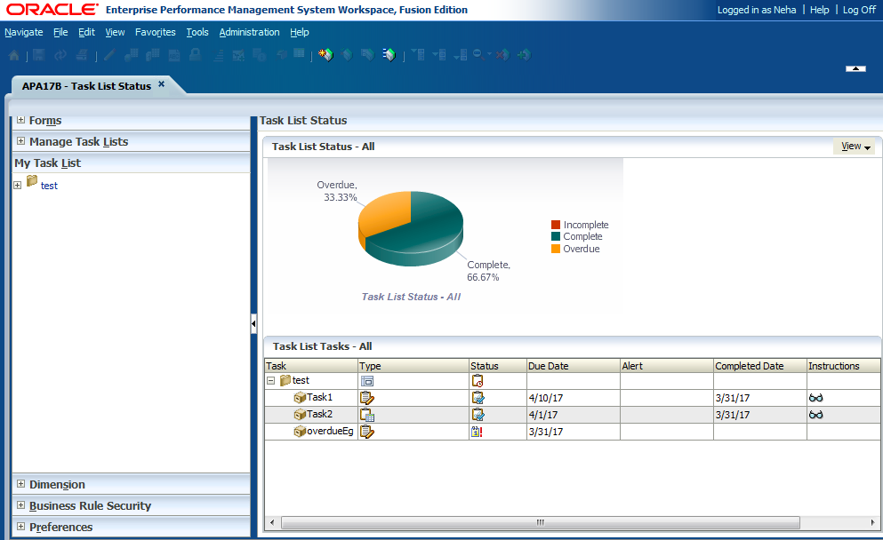

Thus, task list ease the overall tracking of work assigned, the completion and overdue of tasks.

**DRM**

DRM refers to Data Relational Mapping. Oracle Data Relationship Management (DRM) is an enterprise change management solution for building and retaining consistency within master data assets despite endless changes necessary to support underlying transactional and analytical systems.

As companies grow and evolve, it becomes essential to manage master data across information silos that result from mergers and acquisitions, departmental initiatives, or legacy system proliferation. Data consistency, integrity, quality and accuracy suffer and no one trusts the information and insight that ensues. Oracle DRM provides the industry's first data model-agnostic master data management solution built to enable financial and analytical master data management in dynamic, fast-changing business environments.